Sales

Time Series Plot

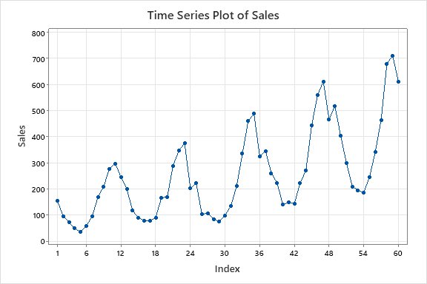

This time series plot exhibits increasing seasonal variation and an upward trend.

ACF

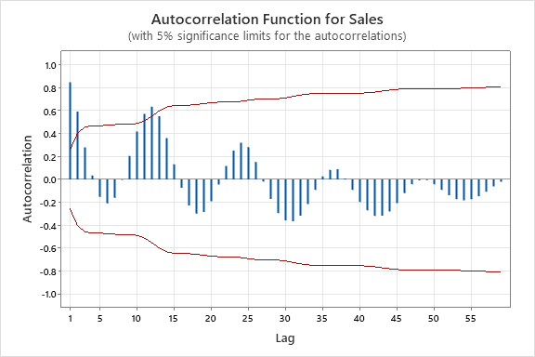

Autocorrelations

Lag ACF T LBQ

1 0.847968 6.57 45.34

2 0.592136 2.94 67.83

3 0.280339 1.23 72.95

4 0.035273 0.15 73.04

5 -0.151781 -0.65 74.59

6 -0.209062 -0.89 77.61

7 -0.160378 -0.67 79.41

8 -0.003115 -0.01 79.41

9 0.204077 0.85 82.45

10 0.417538 1.71 95.42

11 0.572636 2.24 120.31

12 0.636030 2.30 151.67

24 0.320138 0.94 229.73

36 0.084140 0.22 309.55

48 -0.007599 -0.02 409.81

Since there is a seasonal pattern, series is non stationary. Therefore, we have to do a seasonal difference.

Seasonally Differenced Data

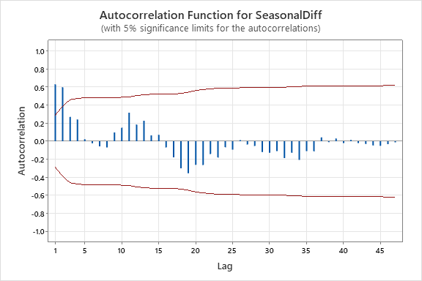

Autocorrelations

Lag ACF T LBQ

1 0.631862 4.38 20.39

2 0.598752 3.09 39.09

3 0.269385 1.18 42.96

4 0.242194 1.03 46.16

5 0.021873 0.09 46.19

6 -0.022643 -0.09 46.22

7 -0.056042 -0.23 46.40

8 -0.069725 -0.29 46.69

9 0.097832 0.41 47.28

10 0.149890 0.62 48.70

11 0.315879 1.29 55.17

12 0.185328 0.73 57.46

24 -0.067836 -0.23 99.68

36 -0.112296 -0.37 126.77

PACF for seasonally differenced data

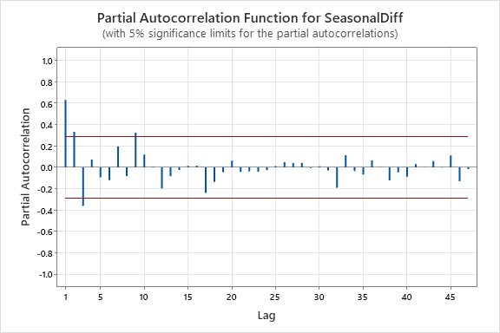

Tentative Model

SARIMA(0,0,2)(0,1,0)12

H0: All coefficientsare constant